Eclipse Git

1. Git support for Eclipse
Via the Eclipse IDE you can perform Git commands like staging, commit, merge, rebase, pull and push.
2. Installation of Git support into Eclipse
Most Eclipse IDE distributions from Eclipse.org already contain support for Git.
In this case no additional installation is required.
If the Git tooling is not available, you can install it via the Eclipse installation manager.
Select the Help Install new Software…​ menu entry. Enter the following update site URLs:
# Use this update site to get the latest release
https://download.eclipse.org/egit/updates

The dialog to install the Git Integration for Eclipse is depicted in the following screenshot.
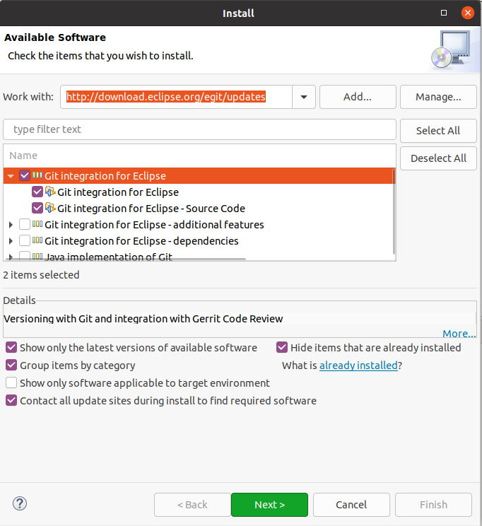
3. Configuration for Git usage via the Eclipse IDE
Interoperability of Git command line settings with the Eclipse IDE
If you have already configured Git for the command line, no additional setup is required in the Eclipse IDE and you can skip this exercise.
The Eclipse IDE uses the same configuration files as the Git command line tools.
This makes it easier to use the Eclipse Git tooling and the command line tooling for Git interchangeably.
3.1. Configure user and email
In your Eclipse IDE, select the Window Preferences Version Control (Team) Git Configuration entry. Configure your full name and email in the user settings. As the Eclipse IDE uses the same settings as the Git command line, this might already be done.
For the user the user.name key is used, for the email the user.email key is used.
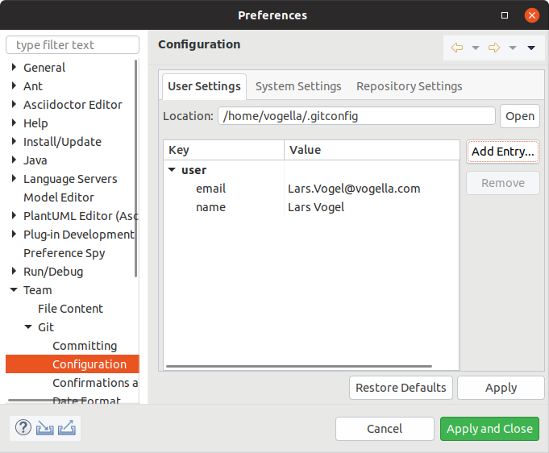
If these keys are not available press the Add Entry…​ button and add them.
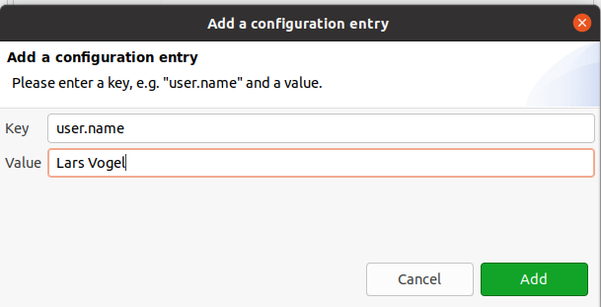
Repeat the procedure for your email address via the user.email key.
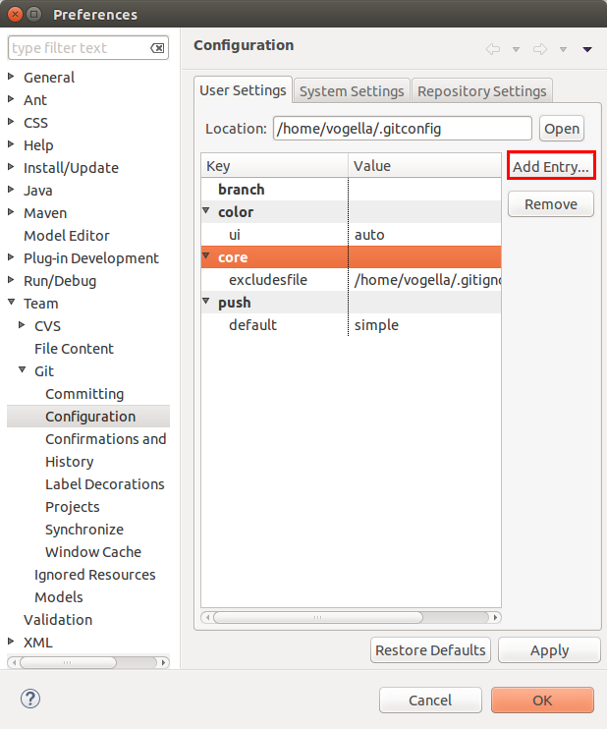
3.2. Configure Git to rebase during pull operations
To use rebase during the pull operation set the pull.rebase parameter to true.
It avoids merge commits if you pull from a remote repository and have divergent changes and instead rebases your local branch on the remote branch it tracks.
This is the recommended setting by the author of this text.

3.3. Validate the setup
After this setup, the configuration should look similar to the following screenshot.
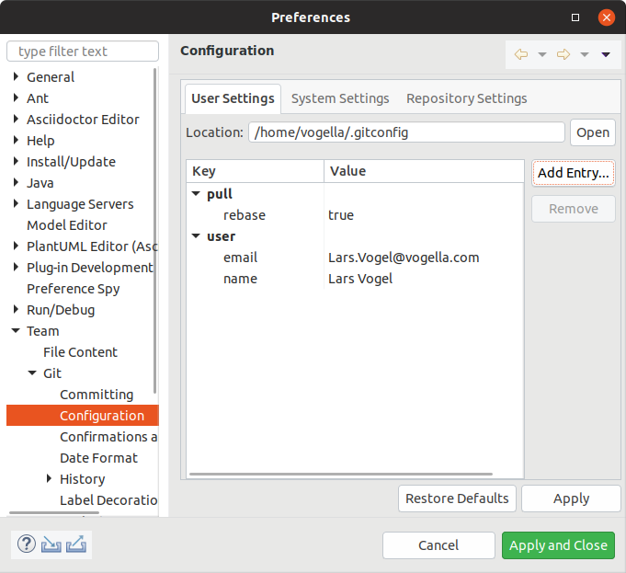
3.4. Configuring the proxy settings
If you are using a proxy server, you can configure it via Windows Preferences General Network Connection.

4. Exercise: Create and using a Git repository with the Eclipse IDE
The following exercise explains how to use the Eclipse IDE to perform Git operations.
To ensure that you have a Git repository, you first create a new local Git repository via the Eclipse IDE.
The Eclipse workspace and Git repositories
It is a good practice to place your Git repositories outside the Eclipse workspace.
This separates your Git repository from any additional metadata which Eclipse might create.
By default, Eclipse Git uses the git folder in the user’s home directory to clone new repositories.
4.1. Create a new Git repository via Eclipse
Use Ctrl+3 (or Cmd+3 on macOS) and type Create a new Git repository in the dialog.
This opens a dialog that allows you to specify the directory for the new Git repository. Select a new directory outside your workspace.
By convention, this directory is a subdirectory in the git folder of the user’s home directory.
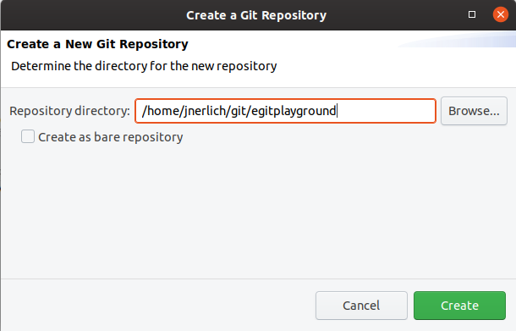
Press the Create button. Now the Git repository is created and a reference to it is added to the Git Repositories view which you use later.
4.2. Create .gitignore file
We want to ignore certain file types in our Git repository.
We want Git to ignore the bin folder and *.class files.
Create a .gitignore file in the top-level folder of your Git repository.
This means, the file should be placed at the same level as the .git directory.
Eclipse Git does not allow you to create a file directly in the top-level folder of your repository.
You have to do this step outside the Eclipse IDE, either via the command line or via your system project explorer.
It should contain the following content.
bin
*.class
Recent versions of MS Windows decided to prevent you from renaming a file in the file explorer without using a file extension. Create a file in Notepad or Editor (new name for Notepad) and select Save-As. Ensure you have removed the .txt extension.
4.3. Create a new Java project
Projects in Eclipse are folders that can have a special configuration, e.g., they can be configured to support Java development. Use Ctrl+3 (or Cmd+3 on macOS) and type Create a Java project to open the wizard to create a Java project.
Enter com.vogella.git.first as name and leave the rest of the values to their default value.
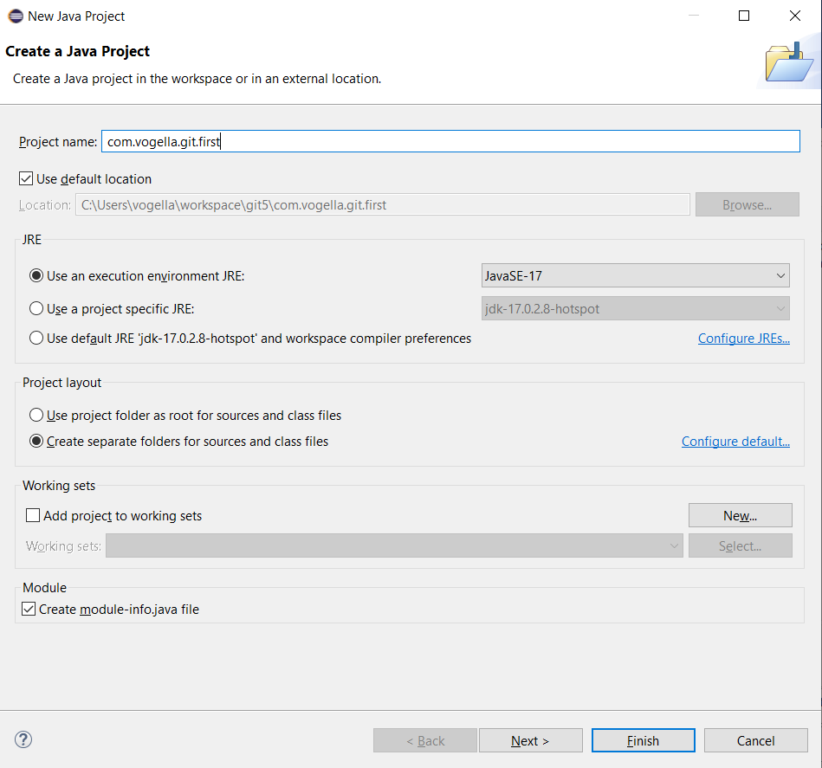

Accept the default values for a module-info.java file and press Create .
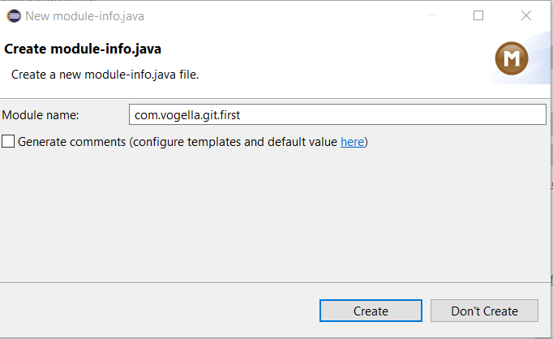
If you are using Java 8 or lower, you will not be asked to create a module-info.java.
4.4. Optional: Create some Java content
Skip this part of the exercise in case you are not familiar with Java and go directly to the next part.
Use Ctrl+3 (or Cmd+3 on macOS) and type Create a Java class to open the wizard to create a Java class. Enter:
- com.vogella.git.first as package
- GitTest as Name
Leave the rest of the values to their default value. Press the Finish button, this creates the class and opens the editor.
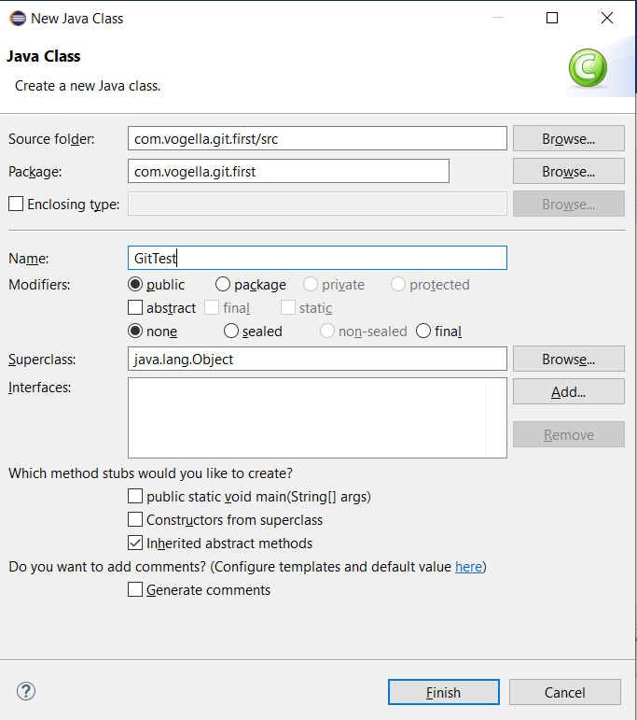
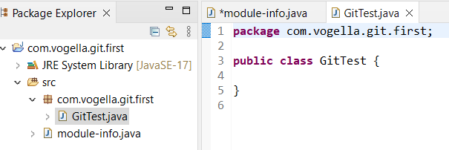
Now change the code of the class to the following.
package com.vogella.git.first;

public class GitTest {
public static void main(String[] args) {
System.out.println("Git is fun");
}
}
4.5. Put project under Git version control
To put your new project under version control with Git, right-click on your project, select Team Share Project. If another version control system is installed you have to select that you want to use Git as the version control system.
Select your existing Git repository from the drop-down list.
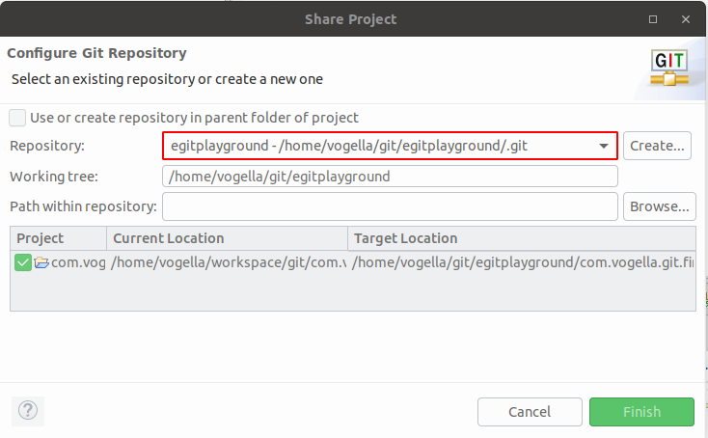
Press the Finish button.
Your project location has now moved into the folder of the Git repository.
4.6. Open the Git repository view
Use Ctrl+3 (or Cmd+3 on macOS) and type Git Repositories in the dialog to open the Git repositories view. This view shows you the Git repositories you can work with in Eclipse and allows you to add existing repositories to Eclipse, create or clone repositories. It allows you to perform Git operations.
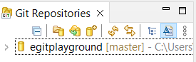
4.7. Using the Git Staging view for the initial commit
Use Ctrl+3 (or Cmd+3 on macOS) and type Git Staging to open the Git staging view.
In this view use the ++ button to stage all files. Write a meaningful commit message and press the Commit button.
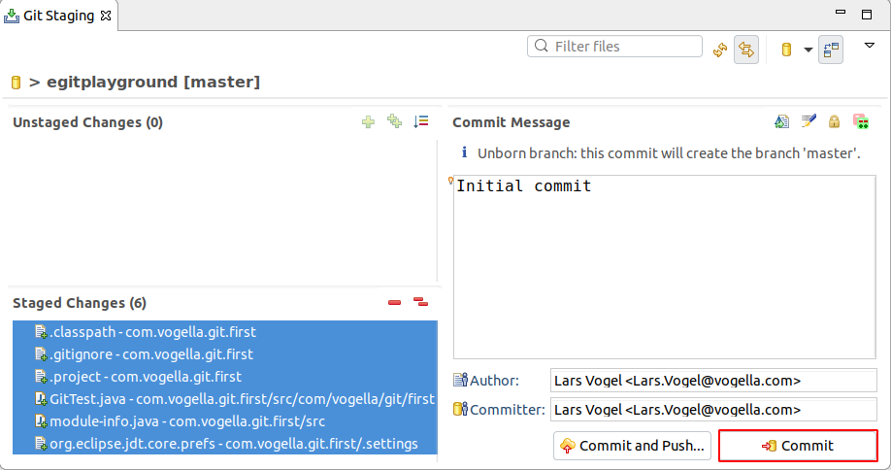
4.8. Create a new file
Create a new file named Readme.txt via right-click on your project and New File from the context menu. Do not commit it yet.
4.9. Change a file and commit the change
If you did not do the optional Java part, skip this part of the exercise also.
Otherwise, change the System.out.println message in your GitTest class.
package com.vogella.git.first;

public class GitTest {
public static void main(String[] args) {
System.out.println("Git is cool");
}
}
Commit the changes of the GitTest class, but do not add and commit the Readme.adoc file to the Git repository.
In the Git Staging view drag only the GitTest class into the Staged Changes area, write a meaningful commit message and press the commit button.
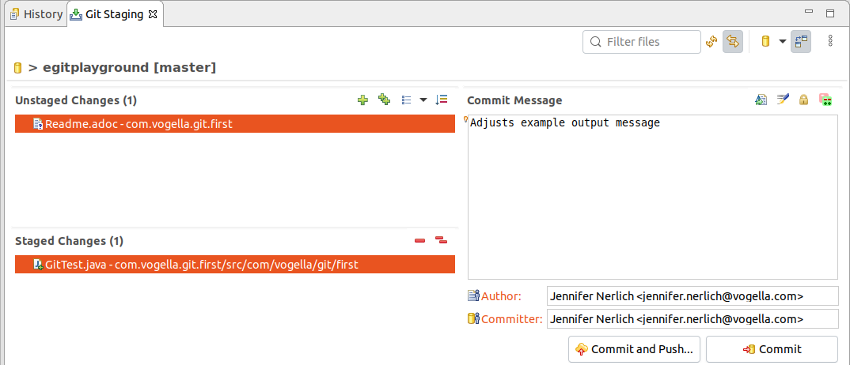
This change is now stored in your local Git repository. The Readme.adoc file is neither staged nor committed to the Git repository.

